How to change powerline network name?
Step 1: Open bowser and enter plc.tendawifi.com in address bar to login the setup page.
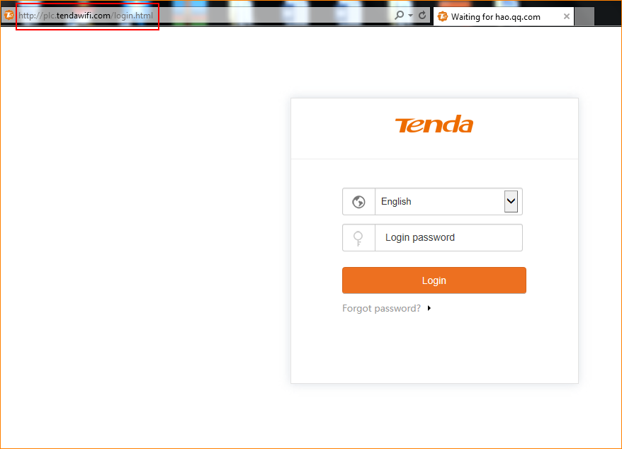
Step 2: Choose powerline list. And pay attention to “PLC Network Settings”.
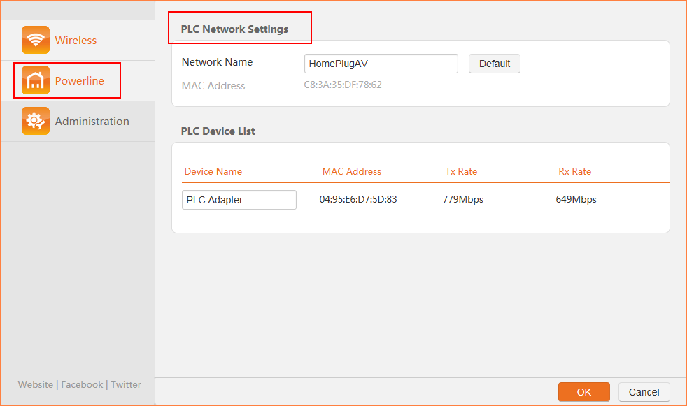
Step 3: Change the “Network Name” and tap “OK” to save the settings.

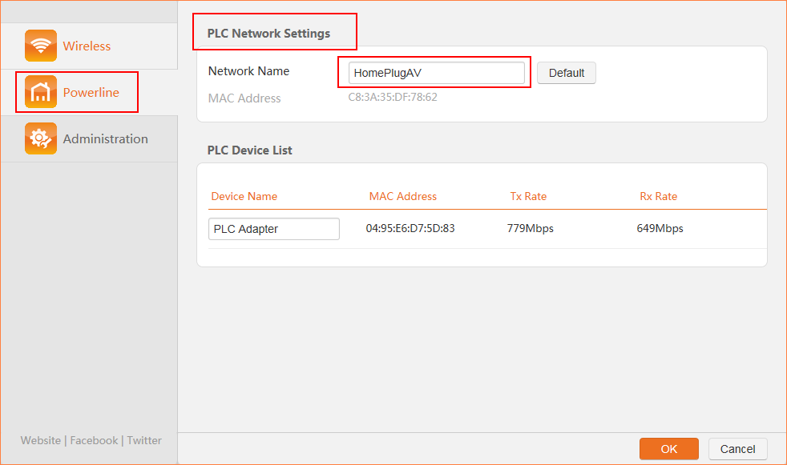
Note: If you change the Network Name of PA6, it will exit from the current powerline network after the settings take effect. Network Name specifies the name of the powerline network where PA6 resides. The default powerline network name is HomePlugAV which indicates that this is an unencrypted powerline network.

